****Example -1****

Let’s see an example of the Apriori Algorithm.

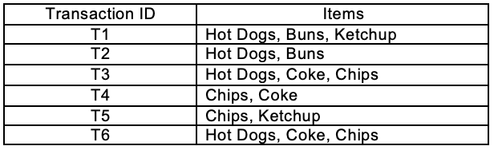

Find the ****frequent itemsets**** and generate ****association rules**** on this. Assume that minimum support threshold (s = 33.33%) and minimum confident threshold (c = 60%)

Let’s start,

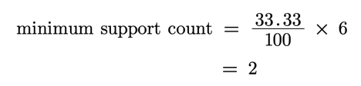

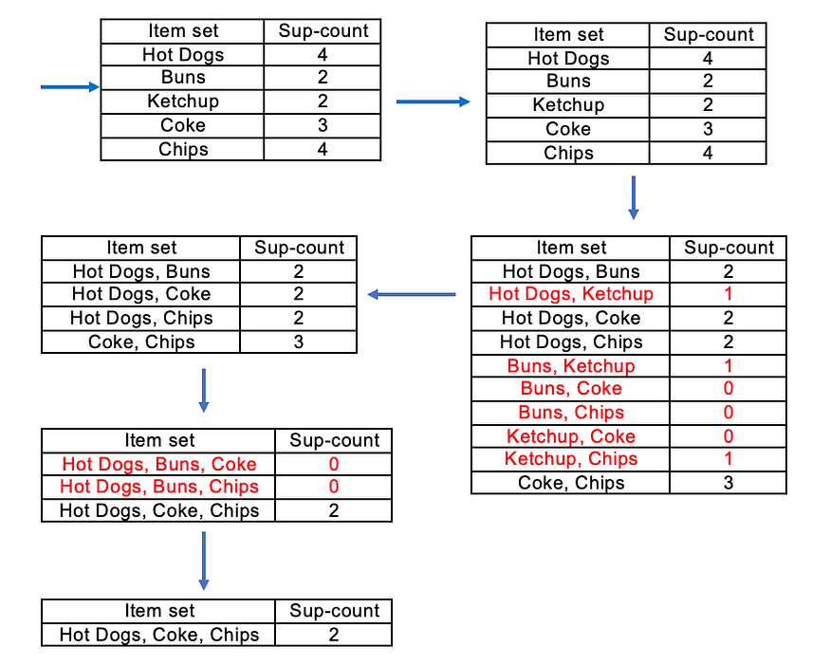

There is only one itemset with minimum support 2. So only one itemset is frequent.

****Frequent Itemset (I) = {Hot Dogs, Coke, Chips}****

****Association rules,****

* [Hot Dogs^Coke]=>[Chips] //confidence = sup(Hot Dogs^Coke^Chips)/sup(Hot Dogs^Coke) = 2/2*100=100% //****Selected****
* [Hot Dogs^Chips]=>[Coke] //confidence = sup(Hot Dogs^Coke^Chips)/sup(Hot Dogs^Chips) = 2/2*100=100% //****Selected****
* [Coke^Chips]=>[Hot Dogs] //confidence = sup(Hot Dogs^Coke^Chips)/sup(Coke^Chips) = 2/3*100=66.67% //****Selected****
* [Hot Dogs]=>[Coke^Chips] //confidence = sup(Hot Dogs^Coke^Chips)/sup(Hot Dogs) = 2/4*100=50% //****Rejected****
* [Coke]=>[Hot Dogs^Chips] //confidence = sup(Hot Dogs^Coke^Chips)/sup(Coke) = 2/3*100=66.67% //****Selected****
* [Chips]=>[Hot Dogs^Coke] //confidence = sup(Hot Dogs^Coke^Chips)/sup(Chips) = 2/4*100=50% //****Rejected****

There are four strong results (minimum confidence greater than 60%)